UI Design Comparison Report
Title
Comparison of the User Interface Design of Gmail and Outlook
Submitted By
- Name: Shanthini Jayashree J
- Register Number: 261CB021
- Class: I BCA
- Subject: UI & UX
- Date:04/08/2026

1. Aim
To compare the User Interface (UI) design of two mobile applications and identify their strengths, weaknesses, and usability based on visual design elements.

2. Applications Selected
Application 1: Gmail
Application 2: Outlook
Reason for Selection: Gmail and Outlook are email and communication applications with different interface designs and feature sets. Comparing them helps identify the differences in color, typography, buttons, navigation, layout, icons, and overall usability.

3. Introduction
User Interface (UI) refers to the visual elements through which users interact with an application. A good UI should be attractive, simple, and easy to understand. This report compares the UI design of Gmail and Outlook based on different design aspects.

4. Comparison of UI Elements
4.1 Home Screen
Gmail has a clean and simple home screen with fewer options. Frequently used features are clearly displayed.
Outlook provides many services on the home screen, making it feature-rich but slightly crowded. 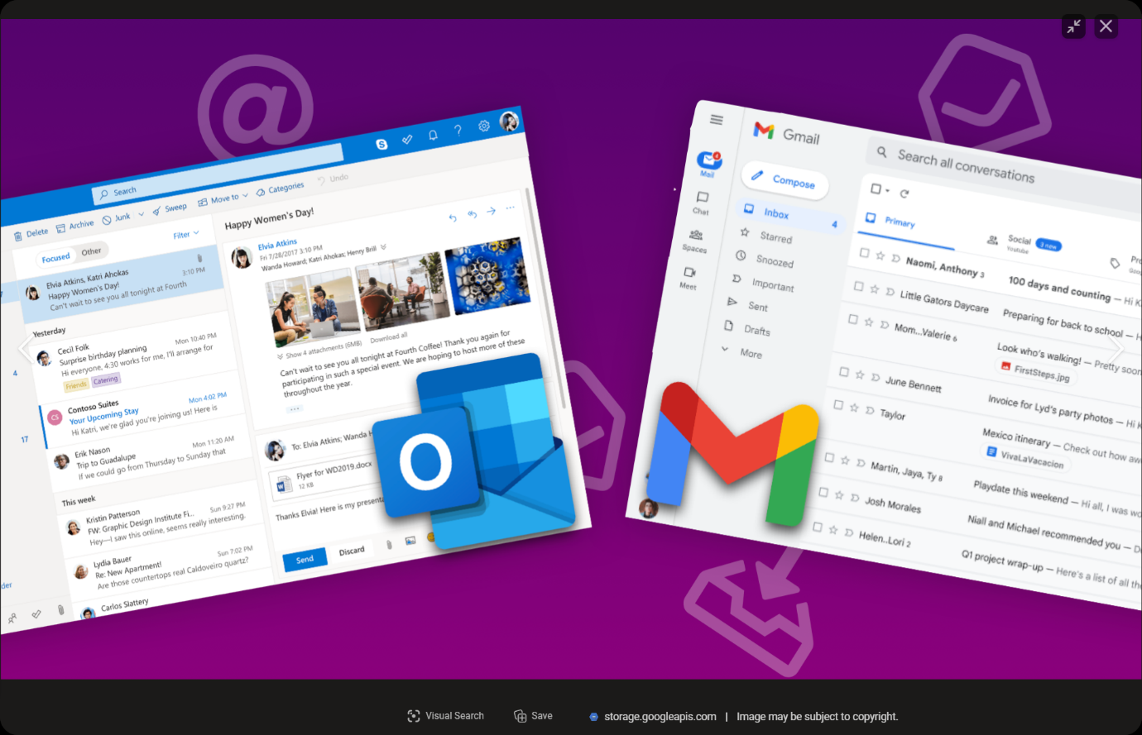
Observation: Gmail is easier for first-time users.

4.2 Color Scheme
Gmail uses a white background with Google colors—red, blue, yellow, and green—in its branding.
Outlook mainly uses a blue and white theme, giving it a clean, professional, and modern appearance.
Observation: Gmail looks minimal, while Outlook appears more vibrant.

  - Typography
Gmail uses clear fonts, readable sizes, and bold headings.
Outlook uses readable fonts and different sizes for important text.
Observation: Both applications have readable fonts.

4.4 Icons
Gmail uses a colorful M logo and simple icons.
Outlook uses a blue O and envelope logo with clear icons.
Observation: Both have recognizable branding.

4.5 Buttons
Gmail provides large action buttons for payments and scanning QR codes.
Outlook also provides visible buttons but includes more shortcut options.
Observation: Gmail’s buttons are easier to identify.

5. Comparison Table
UI Feature | Gmail | Outlook
Color | White background with Google colors in branding. | Blue and white theme.
Buttons | Simple and easy to find. | Clear buttons with more options.
Navigation | Simple side menu; easy to use. | Folders and menu options; well organized.
Fonts | Clean and easy-to-read fonts. | Professional and readable fonts.
Layout | Simple and clean. | Structured with more features.
Icons | Simple and colorful icons. | Professional and clear icons.
Overall | Best for simple and quick email use. | Best for professional and business email use.

6. Strengths and Weaknesses
Gmail
Strengths
- Easy Email Management
- Built-in Calendar
- Strong Security
Weaknesses
- Limited Free Storage
- Internet Required
- Privacy Concerns

Outlook
Strengths
- Built-in Calendar
- Microsoft Office Integration
- Strong Security
- Email Organization
Weaknesses
- Can Be Complex
- Paid Features
- Uses More System Resources

8. Conclusion
Outlook is a reliable tool for email, calendar, and task management. It improves communication, organization, and productivity. It is widely used by businesses, students, and professionals.

